OBESITY AND LAPARPSCOPY
DR S.M.SENTHIL NATHAN
SENIOR ASSISTANT PROFESSOR
COIMBATORE MEDICAL COLLEGE.
Mail -drnathas@gmail.com

Obesity has become the main pandemic of the century and a major health problem, The prevalence of obesity in India in 2011 was 10.4 and 10.9 percent in males and females .One in every eight person you are going to anaesthetise will be an obese person. Any person with a Body Mass Index ( BMI—weight in kgs/ square of Height in metres) of 30 and above is termed as an obese person.
According to recent WHO guidelines obesity has been classified into
Body mass index;
kg.m2 Classification

< 18.5 Underweight
18.5–24.9 Normal
25.0–29.9 Overweight
30.0–34.9 Obese 1
35.0–39.9 Obese 2
> 40.0 Obese 3 (previously
‘morbid obese)
Obesity patients usually present themselves for laparoscopy for two type of surgeries
1. BARIATRIC SURGERIES
Viz. sleeve gastrectomy, bypass surgeries, gastric banding.
2. NON – BARIATRIC SURGERIES
Ex- Laparoscopic cholecystectomy, Total lap hysterectomy.

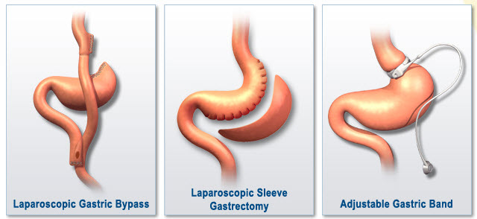

Whether the patient comes for a bariatric or non bariatric surgery the pathophysiology of obesity is the same. Lets just look briefly into the pathophysiology of obesity before anaesthetising the patient.
RESPIRATORY SYSTEM
Normal features of a obese;
Increase in metabolic rate
Increased work of breathing
Increased minute work of breathing
Decresed FRC, Increased atelectasis and shunting.
Sleep disordered breathing;
A spectrum of condition ranging from OSA ( Obstructive sleep apnoea ) to OHS ( Obstructive Hypoventilation syndrome) . This is present in 10 to 20% in all obese persons with BMI >35.
Obesity Hypoventilation syndrome ;
This is a triad of
a. Obesity
b, sleep disordered breathing / OSA
c. Day time Hypercapnia.
Obstructive Sleep Apnoea ( OSA) increases the risk of
A .Postoperative desaturation
b. postoperative respiratory failure
c. Risk of post op cardiac events.
OSA is usually treated with nocturnal CPAP and if not treated may proceed to Obesity hypoventilation syndrome(OHS). This may increase the susceptibility of the patient to opioids and anaesthetic agents and causes delayed recovery and increased risk of postoperative respiratory failure.
CARDIOVASCULAR SYSTEM
Obesity leads on to
a. Increased BP
b. increased cardiac output
c. Increased cardiac workload - leading on to heart failure.
d. Fatty infiltration of conductive system increasing risk of arrythymias
Increase risk of DVT about 10 times greater in obese women.
The risk of DVT is increased in patients undergoing gastric bypass surgeries and will persist for 2 weeks postoperative period.
HORMONAL CHANGES
Obesity is associated with increased insulin resistance.
Gastric bypass is associated with sudden decrease in Insulin requirement.

PREOPERATIVE PREPARATION
Most of the obese patients are safe like normal patients except for the people with central obesity and metabolic syndrome. The risk of sleep disordered breathing and thrombo-embolism should be dealt carefully. The BMI should be calculated for all the patients.
The OS-MRS ( OBESITY SURGERY MORTALITY RISK STRATIFICATION SCORE). This score has been evaluated for patients undergoing bariatric surgery and its risk factors. This shall be used for non-bariatric surgeries also.

The Obesity Surgery Mortality Risk Stratification score:

(a) risk factors; (b) risk of mortality

Risk factor Score

(a)
BMI > 50 kg.m_2 1
Male 1
Age > 45 years 1
Hypertension 1
Risk factors for pulmonary embolism: 1
Previous venous thromboembolism
Venacaval filter
Hypoventilation (sleep-disordered breathing)
Pulmonary hypertension
Risk of mortality

(b)
Class A: 0-1 points 0.2–0.3%
Class B: 2–3 points 1.1–1.5%
Class C: 4–5 points 2.4–3.0%
If the OS-MRS score is greater than 4 to 5 the patient require close post-operative monitoring.

Respiratory Assessment
1.
- Excercise tolerance if possible.
- SpO2
- Spirometry

2. ABG done if
- SpO2 less than 95% in air
- FVC< 3L or FEV1 < 1.5L
- Respiratory wheeze at rest
- Serum HCO3 > 27mmol/L
3. Sleep disordered Breathing
To diagnose sleep disordered breathing this STOP-BANG questionnaire is of great value.
The STOP-BANG screening questionnaire for obstructive sleep apnoea . One point is scored for each positive feature.

Snoring Do you snore loudly
Tired Do you often feel tired, fatigued or sleepy during the daytime? Do you fall asleep in the daytime?
Observed Has anyone observed you stop breathing or choking or gasping during your sleep?
Blood Pressure Do you have, or are you being treated for, high blood pressure?
BMI BMI > 35 kg.m2
Age Age > 50 years
Neck Circumference (measured around Adam’s apple) > 43 cm (17 in) for males, > 41 cm (16 in) for females
Gender Male
A score ≥ 5 indicates Sleep disordered breathing or OSA.
A score ≤ 5 but history of exertional dyspnoea, morning headache and right atrial hypertrophy may indicate presence of OSA.
OSA is best treated for 2 to 3 weeks with CPAP before taking them for surgery. CPAP dependent people are at lower risk than the people who cannot tolerate CPAP. People who don’t require CPAP are the ideal people for day care surgery.
Airway assessment :-
There is always a 50% chance of difficult mask ventilation, difficult laryngoscopy or difficult intubation. Large neck circumference > 60cm is associated with 35% difficult laryngoscopy.
Liver shrinking diet :-
In bariatric surgery in order to shrink the size of the liver and make the access of the stomach technically easy for the surgeon, 2 to 6 weeks of preoperative dieting is advised. This also improves the respiratory function and facilitates laparoscopy surgery. Importance of smoking cessation and plans of early mobilisation is to be explained to the patient.
Cardiac assessment :-
The obese patient should be assessed like any other patient. Yet exercise tolerance cannot be assessed accurately. If assessed shall be a valuable tool. Resting ECG and Echocardiograhy is mandatory to identify any postoperative or perioperative event.
PHARMACOLOGY AND DRUG DOSES:
It’s important to learn about different body weights.
- Total body weight
- Ideal body weight
- Lean body weight
- Adjusted body weight
These weights are used to titrate the drugs during anaesthesia.
Total body weight (TBW) :- The actual weight of the patient
Ideal Body weight( IBW) :- = height (cm) - x (where x =105 in females and 100 in males)
Lean Body weight (LBW) :- 9270×TBW(kg) / 6680+(216×BMI) in Men
9270× TBW(kg) /6680 + (244×BMI) in women
Regardless of total body weight, lean body weight rarely exceeds 100 kg in men and
70 kg in women.
Adjusted Body weight ( ABW) :- = IBW(kg) + 0.4 { TBW (kg) –IBW(kg) }
Drugs to be used based on body weights :-
LEAN BODY WEIGHT ADJUSTED BODY WEIGHT
Propofol (induction) Propofol (infusion; see text)
Thiopental Antibiotics
Fentanyl Low molecular weight heparin
Rocuronium Alfentanil
Atracurium Neostigmine (maximum 5 mg)
Vecuronium Sugammadex
Morphine
Paracetamol
Bupivacaine
Lidocaine

All equipments required for a bariatric surgery such as bariatric table which could withstand a weight of over 200kg, gel pads for padding, and protection, raised step for performing intubation, larger sequential compression devices, warming devices, difficult airway cart.

Induction of General Anaesthesia

Good IV access is mandatory. If access is difficult, forearm veins or the external jugular shall be used. Always anaesthetise the patient in the operating theatre and not in the pre-anaesthetic room in order to avoid the problems of transporting the obese anaesthetised patient and to prevent AAGA. ( Accidental Awareness under General Anaesthesia) , AAGA is due to redistribution of the induction agents into the fatty tissue in obese patient causing quick induction yet a quick recovery and awareness due to redistribution. The patient can himself identify the pressure points in the theatre in supine position if anaesthetised inside the theatre.
Keep the emergency airway cart ready since there is always a chance of difficult airway. Adequate preoxygenation before induction is mandatory for 5 minutes. Since the work of breathing is
normally increased in obese patients ,General anaesthesia with controlled ventilation is always the choice. The following should be followed before mask ventilation and intubation.
- Preoxygenation for 5 min – Increases apnoea time
- RAMPED POSITION --Aids laryngoscopy and intubation. Make sure that the level of tragus is at the line of sternum.
- Arms to the side of the patient—Improves lung mechanism
- Head up position and oral airway—Helps in mask ventilation by pushing he visceras away from the diaphragm.
In 90% of the patients the mask ventilation and laryngoscopy would be normal if all these things are followed.

RAMPED POSITION

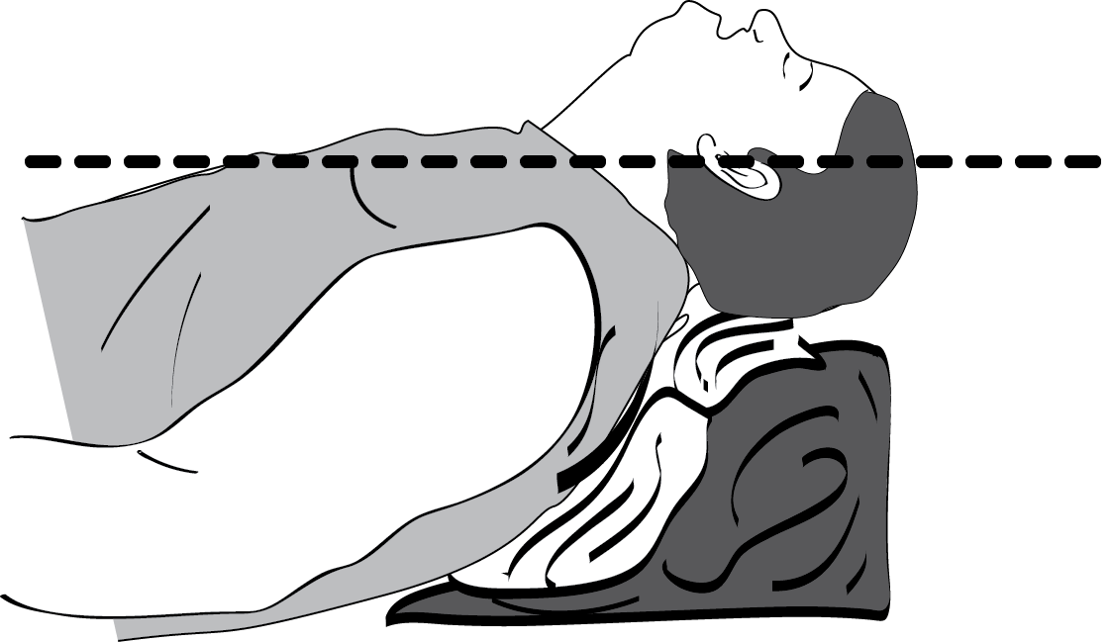

Since suxamethonium induced fasiculations increase oxygen consumption, aminosteroids are a good choice. Rocuronium may be an ideal drug reducing the apnoea time from spontaneous to controlled ventilation and which can be reversed in an emergency by sugammadex. I generally use atracurium most commonly for intubation and maintenance. The tracheal tube sizes should be calculated for ideal body weights.
I best prefer volume controlled ventilation but always keeping an eye on the airway pressure. No ventilation is superior. Frequent change in modes and frequent recruitment manoeuvres and a good PEEP up to 10cm prevents atelectasis of small airways during the intra and post operative period. Mild flexion of trunk (sitting position) improves lung mechanics in bariatric surgery.
Port insertion, CO2 and positioning :-
Multimodal analgesia is the ideal concept. Deep infiltration before port insertion and port removal with local anaesthetic is always done. I prefer infiltration with 1% lignocaine with adrenaline 20 to 30 ml before port insertion and 20 to 30 ml of 0.25% Bupivacaine after removal. Insufflation of CO2 actually reduces the venous return and thereby reduces the BP. But after 15 minutes the BP increases due to increase in systemic vascular resistance because of increase in Pco2. Bariatric surgery needs steep reverse trendelenburg position which will help in dissection. This position itself causes hypotension which is compensated by a normal person, provided the tilt is put slowly in a graded fashion. But yet it may produce a prolonged hypotension in autonomic disturbances
example in diabetics. Proper positioning is mandatory by seeing that all pressure points are properly padded.
Maintenance of anaesthesia :-
- Desflurane or sevoflurane are better, desflurane more ideal than sevoflurane.
- Multimodal analgesia with port infiltration, Paracetamol infusions, NSAIDS and narcotics. The use of narcotics have been significantly reduced because of multimodal approach.
- Neuromuscular blockade best monitored by Nerve stimulators.
- Use of short acting drugs as far as possible.
- Adequate hydration of the patient to prevent Rhabdomyolysis.

Recovery and Emergence :-
Recovery from neuromuscular blockade should be always guided by nerve stimulator. Patient should have good tidal volumes and airway reflexes before extubation. The extubation should be done .Extubation should be done when fully awake and head up position. Ryles tube will be present during extubation, so too much suctioning will cause irritation of the throat which may lead on to retching. Insertion of a nasopharyngeal airway may be helpul at times during extubation of an obese patient.
Postoperative care :-
Patients should be maintained in 45 degrees head up tilt. Oxygenation by mask shall be given to maintain the preoperative Spo2 levels. Early mobilisation is mandatory and key to success of the surgery and prevents the patient from venous thrombosis. Patients who were using CPAP mask earlier shall be reinstated to CPAP in the PACU. Best is to make the patient move by himself to the bed from the operating table. It will be at its best if we make the patient sit in an hour and make him walk with support in 2 hrs.
Patient may be shifted from PACU to the ward if
- Respiratory rate becomes normal
- No episodes of hypopnoea for 1 hour.
- Oxygen saturation returns to normal values without O2 support.

Thromboprophylaxis :-
Since obesity is a major risk factor for venous thromboembolism ( VTE ) measures to prevent VTE should be taken in high precision .Mechanical compression devices, thrombo- embolic stockings and anti-coagulants shall be used.
Enoxaparin 40mg S.C 12 hours before surgery and continued for 2 to 3 days till the patient is fully mobile. If patient is > 100kg then 40mg twice daily is adviced. Oral anticoagulants are not used in obese patients. Following are the high risk patients for VTE.
- BMI > 30
- Age > 60 years
- Surgery time > 90 mins
- Family history of VTE
DAY CARE SURGERY

Day care bariatric surgery for obese is a upcoming concept in foreign countries. Admitting the patient on the day of surgery and discharging the patient on the next day.
Current guidelines for acceptance for day care surgery are
- BMI < 40 with co-morbidities
- BMI > 40 without co-morbidities.
- OSA patients able to use CPAP.
- Laparoscopic gastric banding
- Laparoscopic cholecystectomy.
Laparoscopic hysterectomy :-
Trendelenburg position usually causes increased airway pressure in laparoscopy due to compression of the diaphram by the abdominal viscera. This is more in obese patients. Manual ventilation should be avoided since it cannot maintain the airway mechanics. Adequate mechanical ventilation with volume control and adequate PEEP will maintain the oxygen saturation ad EtCO2 levels inspite of high airway pressures. Proper operation table with support to prevent the obese patient from sliding down during head down position and care should be taken to prevent tube migration. There may be steep increase in systemic pressures after pneumo-peritoneum. This could be counteracted by using beta blockers and vasodilators.
An obese patient is to be anaesthetised with high vigilance, expertise and understanding their pharmacokinetics. It’s better to anaesthetise an obese patient strictly following the above protocols and practises. One must not hesitate to request the surgeon to deflate the abdomen immediately in situations of uncontrollable desaturations and increased EtCO2 values.
REFERENCES
- 1.Anaesthesia and morbid obesity – Sharmin lotia &Mark C Bellasamy
- Peri-operative management of morbidly obese patients –Association of Anaesthetists of Great Britain.2007
- Anaesthesia for Bariatric surgery- - Ana Fernandez-Bustamente 2011
- Textbook of Anaesthesia—Ronald D Miller,8th
- Bariatric surgery-Anaesthesiological concerns----by Johan Raeder, University of Oslo,Norway.
- GUIDELINES-Peri-operative management of obese surgical patients 2015. –Association of Anaesthetists of Great Britain and Ireland, Society for obesity and Bariatric Anaesthesia..
- Practise Guidelines for peri-operative management of patients with Obstructive sleep apnoea.—American society of Anaesthesiology task force, Anaesthesiology 2007.
- Pharamacokinetic considerations in the obese---Best Practices Resp ClinicAnaesthesiol-2011..25

